

Master Property View User Story and Wireframes

Contents
User story- Master Property View 3
1. Master View - Allotted Property 3
1.1 Mock-ups 6
2. Generate an Allotment Letter 10
2.1 Mock-ups 11
3. Generate an Allotment Money Challan 12
3.1 Mock-ups 12
4. Generate a Payment Schedule 14
4.1 Mock-ups 15
5. Upload a document 16
5.1 Mock-ups 17

User story- Master Property View

Master View - Allotted Property

In this user story user should be able to see complete master view of an allotted property. This master view would contain the following information.
1) Applicant Details
2) Property Details
3) Payment Details
4) Transfer/Succession History
5) Lease deed, Possession Details.
6) Completion Details
7) Functional Details
8) Document Details
9) Property Schedule
Note: All above views are separate module which once completed, would be visible in their respective section of master view.
For this sprint, only consider: applicant details, property details, payment details, document details, and property schedule. Document will be updated time to time for further modules.
Besides the view, it would contain the below functionalities:
1) Generate Allotment Letter- Property details tab.
2) Generate Allotment Money Challan- Property details tab.
3) Generate Payment Schedule- Payment details tab.
4) Upload documents- Document details tab.
Other functionality would be updated further, when the scope of master view will increase.

Sprint | 3
User Story ID | 001
User Story Title | View Allotted Property
Actors | Department user
Story | As a department user, I want to view an allotted property.
Pre Conditions | - User should have required access rights.
Business Criteria | - Allotment Money Due Date = Allotment Date + 30 days ( configurable).  - If an allotment entry is no approved then, it would only contain property details information.  - Property Details tab would contain buttons if, allotment is approved.  - Allotment Money Challan  - Allotment Letter  - Payment Details tab would contain the option to generate Payment Schedule.  - Document Details tab would contain the option to upload documents.  - ‘Get Document from DMS’ service would be used to view a document.
Acceptance Criteria | - User would click on RID available in grid against each Allotment added.  - User would get a master view screen which contains the following tabs with information  Property details- This would contain the applicant and property information.  Applicant Details  - Form Number  - Applicant name  - Gender  - Father’s Name  - Mobile Number  - Signing authority (in case of company as gender)  - Registered Office (in case of company as gender)  - Occupation  - Category  - Religion  - Annual Income  - PAN Details  Property Details  - RID  - Scheme Name  - Department  - Property Type  - Sector  - Block  - Floor (in case of Housing)  - Property Number  - Total Area (Sq. Mtr.)  - Property Cost (Housing department)  - Civil Cost (Housing department)  - Land rate(sqmt) (Other Departments)  - Total Property Cost  - Location Type  - Location Charge  - Total No of Installment  - Allotment Money  - Allotment Date  - Installment Start Date  Payment details- This would contain payment schedule and payment history details.  - Basic applicant details:  - Applicant Name  - Father’s Name  - Gender  - Department  - Property type  - Property No/Plot No  - Total Dues Information  - Payment Schedule (displayed in a grid)  - Installment Number  - Installment Due Date  - Principal Amount  - Principal Installment amount  - Interest Installment amount  - Payment History (displayed in grid)  - Receipt No  - Payment Head  - Payment Subhead  - Challan No  - Deposit Date  - Amount Paid  Document details- to view and upload documents related to property.  - View Uploaded Documents (displayed in grid)  - Serial Number  - Document Type  - Document Name  - Document Path (link to view document)  User would click on link under the column of document path to view the uploaded document.  - Upload Document.  Property Schedule- to view schedule dates of important events of a property.  - Steps to display progress of events of a property, successful events would be clearly indicated in the steps along with the upcoming events.  - Schedule Grid  - Serial Number  - Process Name  - Due Date  - Actual Execution Date  Other Details to be updated…
Field level Validation

Mock-ups

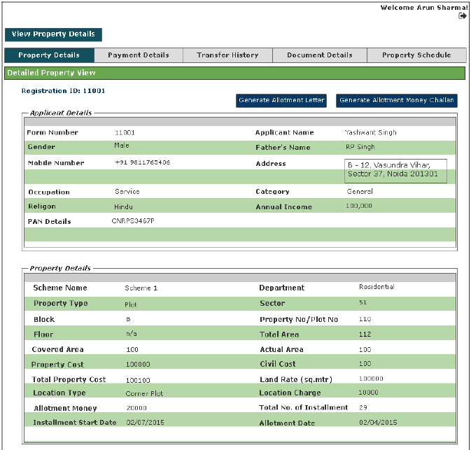

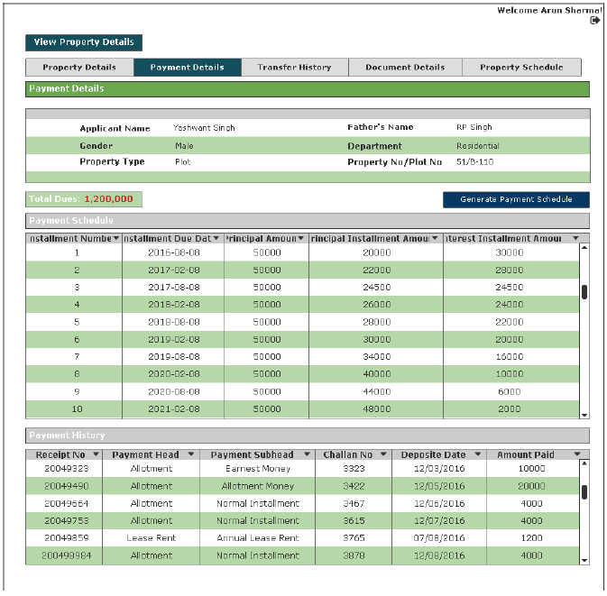

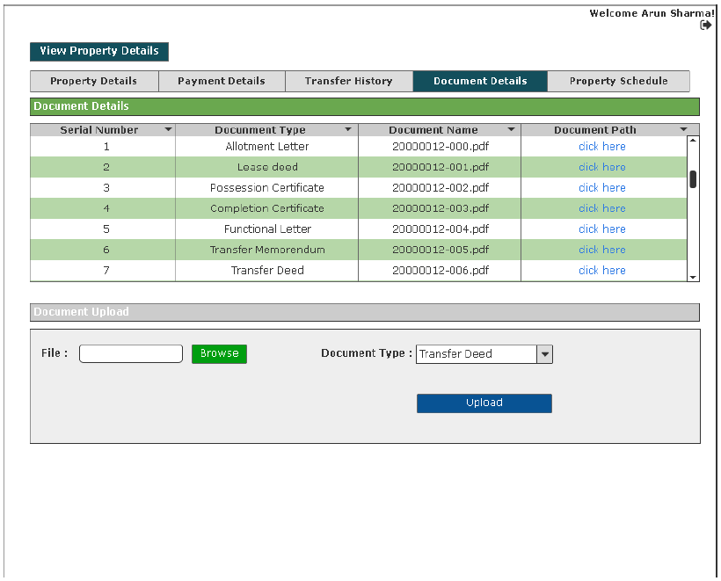

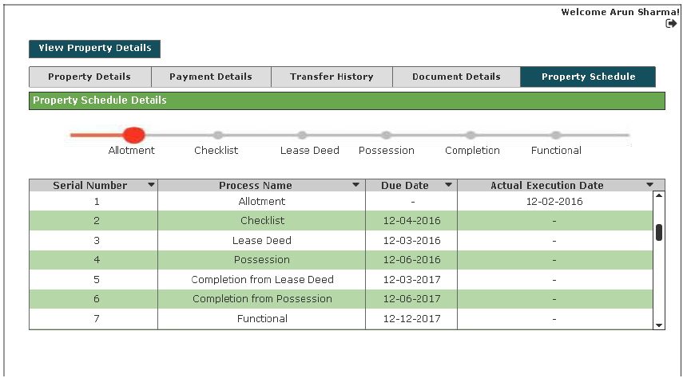

Generate an Allotment Letter

Sprint | 3
User Story ID | 002
User Story Title | Generate an Allotment Letter
Actors | Department user
Story | As a department user, I want system to generate an allotment letter to the customer.
Pre Conditions | - User should have required access rights.  - Allotment should be approved.
Business Criteria | - Allotment letter would be generated only for approved allotment of property.
Acceptance Criteria | Navigation: Manage Allotment -> View -> Property Details -> ‘Allotment Letter’  - User would click on ‘Allotment Letter’ and allotment letter for the approved allotment would be generated and displayed on the application screen.  - User would have the options to print allotment letter by clicking on ‘Print’ button.
Field level Validation

2.1 Mock-ups

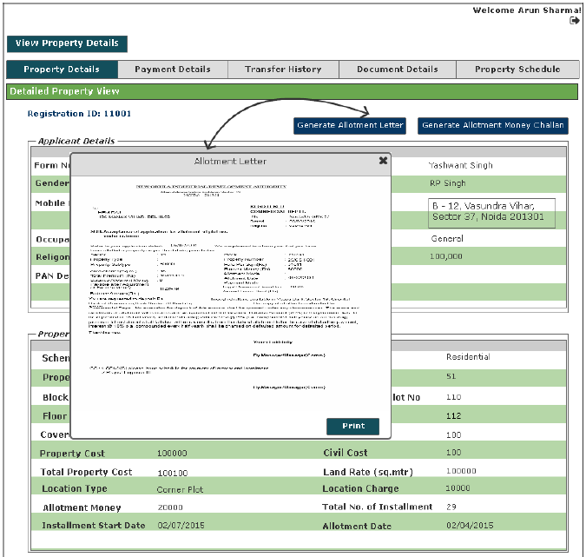

Generate an Allotment Money Challan

Sprint | 3
User Story ID | 003
User Story Title | Generate an Allotment Money Challan
Actors | Department user
Story | As a department user, I want system to generate an allotment money challan to the customer.
Pre Conditions | - User should have required access rights.  - Allotment should be approved.
Business Criteria | - Allotment Money Challan would be generated only for approved allotment of property.
Acceptance Criteria | Navigation: Manage Allotment -> View -> Property Details -> ‘Allotment Money Challan’  - User would click on ‘Allotment Money Challan’ and allotment money challan for the approved allotment would be generated and displayed on the application screen.  - User would have the options to print allotment money challan by clicking on ‘Print’ button.
Field level Validation

Mock-ups

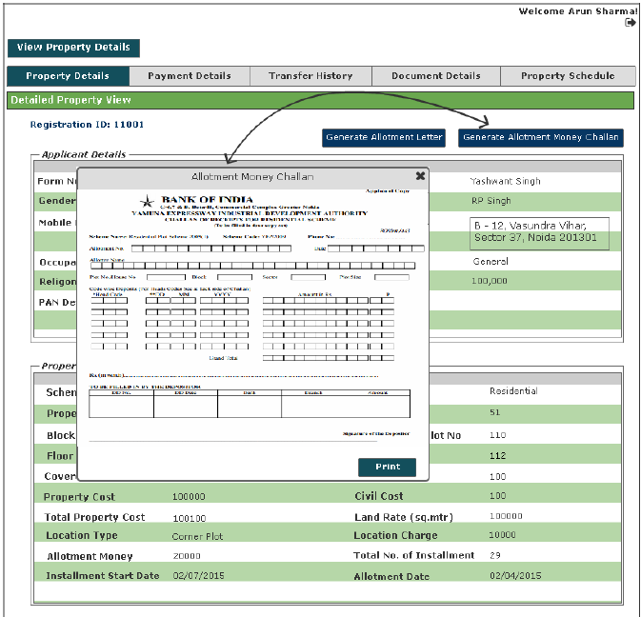

Generate a Payment Schedule

Sprint | 3
User Story ID | 004
User Story Title | Generate a Payment Schedule
Actors | Department user
Story | As a department user, I want system to generate a payment schedule to the customer.
Pre Conditions | - User should have required access rights.  - Allotment should be approved.
Business Criteria | - Payment Schedule would be generated only for approved allotment of property.  - For 'Housing' and 'Industrial' department payment schedule is created on equated monthly basis.  - For 'Residential', 'Commercial’, 'institutional' and 'Group Housing' department payment schedule is created on reducing monthly basis.  - Frequency of installment would be yearly (1), half yearly (2), Quarterly (4), Monthly (12).  Payment Schedule- Reducing Monthly installments (for detailed description please refer to Excel Sheet)  Total Premium Balance Amount = Total Cost of property – (allotment money + earnest money)  Principal Amount= Total Premium Balance Amount/No. of Installments  First Installment Interest Calculation = [Total Premium Balance Amount * (Rate of Interest/Frequency)]/100  The first installment in reducing monthly installment method can be calculated as:  Premium Balance Amount = Premium Balance Amount - First Installment Principal Amount  From First Installment Interest onwards,  Second Installment Interest Calculation = [Balance Premium Amount *(Rate of interest/Frequency)]/100  Premium Balance Amount = Premium Balance Amount - Second Installment Principal Amount  Similarly,  Nth Installment Interest Calculation = [Balance Premium Amount *(Rate of Interest/Frequency)]/100  Premium Balance Amount = Premium Balance Amount - nth Installment Principal Amount  Payment Schedule- Equated Monthly Installments (for detailed description please refer to Excel Sheet)  Rate of Interest, r = (N.I. / (12/f))  Where, F=frequency;=1(yearly),f=2(halfyearly),f=4(quarterly),f=12(monthly)  N.I. = Normal Interest  n = Number of installment  The factor can be calculated as  Factor, F = [POW ((1+r/100), n) * r/100] / [POW ((1+r/100), n)-1]  So, the installment amount can be calculated as the product of Balance Amount and the Factor (calculated using the above formula), i.e.:  Installment Amount = Balance Amount * Factor  Calculate outstanding payment at any point of time against a payment schedule  Dues are calculated e.g., if an instalment is missed, it is marked as dues. Penal interest is applicable on dues  In case customer pay partial amount before due date of next instalment then, reconciliation takes place and penal interest is applicable  - Till date on the amount dues.  - Up to the due date for next instalment, on dues remaining (dues minus partial payment)  In case customer pays amount on due date then reconciliation takes place on due date.  Penal Interest = P*(1+r/100) ^ n  Where,  P = Principal  r = rate of interest  n = frequency
Acceptance Criteria | Navigation: Manage Allotment -> View -> Payment Details -> ‘Payment Schedule’  - User would click on ‘Payment Schedule’ button and payment schedule for the approved allotment would be generated and displayed on the application screen.  - User would have the options to print payment schedule by clicking on ‘Print’ button.
Field level Validation

Mock-ups

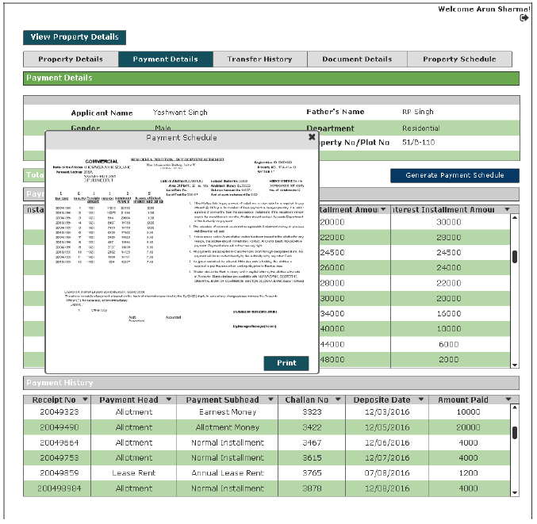

Upload a document

Sprint | 3
User Story ID | 005
User Story Title | Upload property related documents
Actors | Department user
Story | As a department user, I want to upload property related documents
Pre Conditions | - User should have required access rights.  - Allotment should be approved.
Business Criteria | - ‘Post Document to DMS’ service would be used to upload a document.
Acceptance Criteria | Navigation: Manage Allotment -> View -> Document Details  - User would click on browse button, to select the file to be uploaded.  - User would select the document type from the dropdown.  - User would click on upload button to upload document.
Field level Validation | - File: Maximum file size would be 150Kb. Only jpg and png format allowed.

Mock-ups
